**#Python program to show if conditions.**

num1=int(input("Enter a number:"))

if num1%5==0:

print(num1,'is multiple of 5')

print(str(num1)+ 'is multiple of 5')

if num1%5!=0:

print(num1, 'is not multiple of 5')

print(str(num1)+'is not multiple of 5')

**OUTPUT**

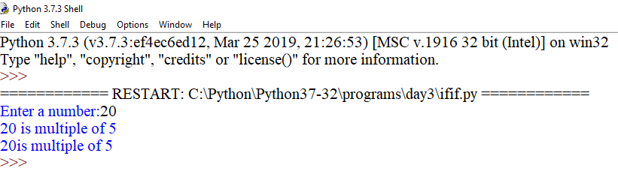

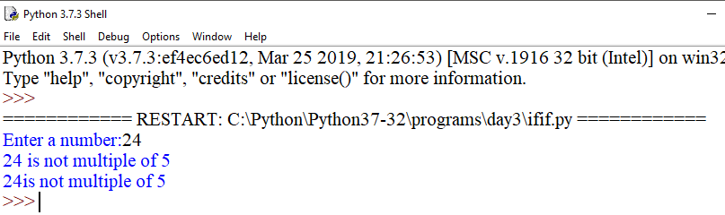

**#Python program to show if-else conditions.**

num1=int(input("Enter a no."))

if num1%2==0:

print(num1,'is even')

print('if block code executed')

else:

print(num1,'is odd')

print('else block code executed')

**OUTPUT**

